1. **Swap two numbers using temporary variable**

Input :

#include <stdio.h>

int main () {

int a,b,c ;

printf ( " Enter the values of a and b \n ") ;

scanf ( "%d%d",&a,&b) ;

printf ( " a = %d \n",a ) ;

printf ( " b = %d \n",b) ;

c = a ;

a = b ;

b = c ;

printf ( " The value of a after swapping = %d ",a) ;

printf ( " The value of b after swapping = %d ",b ) ;

return 0 ;

}

Output :

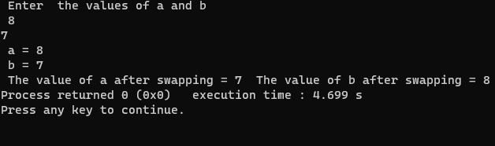

**2) Swap two numbers without using temperary variable**

Input :

#include <stdio.h>

int main ()

{

int a,b,c ;

printf ( " Enter the value of a and b \n") ;

scanf ( "%d %d",&a,&b) ;

printf ( " The value of a is %d \n ",a) ;

printf ( " The value of b is %d \n",b) ;

a = a+b ;

b = a-b ;

a = a-b ;

printf ( " The value a after swapping is %d \n",a) ;

printf ( " The value a after swapping is %d \n",b) ;

return 0 ;

}

Output :

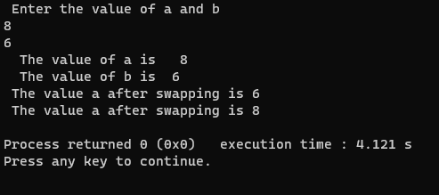

**3) Convert temperature from degree celsius to degree fahrenheits**

Input :

//Converting temperature from degree celsius to degree fahrenheits

#include <stdio.h>

int main () {

float c,f ; // c stands for temperature in degree celsius,f stands for temperature in degree fahrenheits

printf ("Enter the temperature in degrees celsius here : \n") ;

scanf ("%f",&c) ;

printf ("The temperature in degrees celsius is %f C \n",c) ;

f = (9 * c /5) + 32 ;

printf (" The temperature in farenheits is : %f F",f) ;

return 0 ;

}

Output :

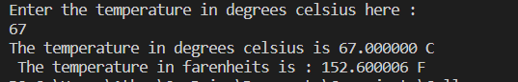

**4) Convert temperature from degree fahrenheits to degree celsius**

Input :

// Converting temperature from degree fahrenheit to degrees celsius

#include <stdio.h>

int main () {

float c,f ; // c stands for temperature in degrees celsius while f stands for temperature in fahrenheit

printf ("Enter the temperature in fahrenheit here : \n") ;

scanf ("%f",&f) ;

printf ("The temperature in degrees fahrenheit is %f F \n",f) ;

c = (f - 32) *5/9 ;

printf (" The temperature in degree celsius is : %f C ",c) ;

return 0 ;

}

Output :

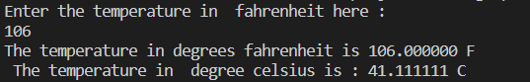

**5) Calculate simple interest**

Input :

// Calculating simple interest

#include <stdio.h>

int main () {

float p,r,t,s ; // p stands for principal amount in bank , r stands for rate of interest of the bank , t stands for time period in years s stands for simple interest

printf ( " Enter the principal amount in bank , rate of interest of the bank , time period in years \n") ;

scanf ( "%f %f %f",&p,&r,&t) ;

printf ( " The principal amount in bank is :Rs %f \n",p) ;

printf ( " The rate of interest of bank is : %f percent \n",r) ;

printf ( " The time period is : %f years \n",t) ;

s = p * r * t /100 ;

printf ( " The simple interest is %f years is Rs %f \n",t,s) ;

return 0 ;

}

Output :

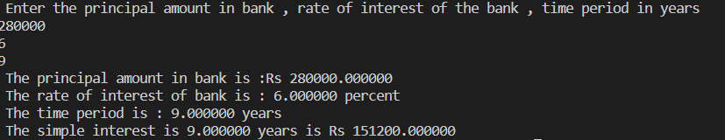

**6) Calculate Volume of cylinder**

Input :

// Calculate the volume of cylinder

# include <stdio.h>

int main () {

float h,r,v ; /* h stands for height of cylinder while r stands for radius of base of cylinder v stands for volume of cylinder */

printf (" enter the height of cylinder , radius of base of cylinder : \n") ;

scanf ( "%f %f ",&h,&r) ;

printf (" The height of cylinder : %f units \n",h) ;

printf (" The radius of base of cylinder : %f units \n",r) ;

v = 3.14 * r * r * h ;

printf (" The volume of cylinder is : %f units \n",v) ;

return 0 ;

}

**Output :**

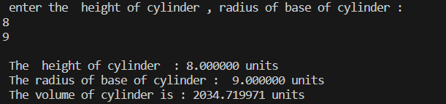

**7) Calculate the area and circumference of a circle**

Input:

//Calculate the area and circumference of a circle

#include <stdio.h>

Int main ( ) {

float r,c,a ; // r stands for radius of the circle ,c stands for the circumference of the circle while a is the area of the circle

printf (“Enter the radius of the circle : \n”);

scanf (“%f,&r);

printf (“The radius of the circle is %f units \n”,r);

c = 2 * 3.14 * r ;

printf (“The circumference of the circle is %f units \n”,c);

a = 3.14 * r * r ;

printf (“The area of the circle is %f units \n”,a);

return 0 ;

}

Output :

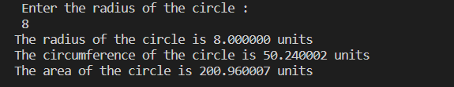

**8)Calculate the sum and average of four numbers (with decimal points)**

Input :

// Calculate the sum and average of four numbers

#include <stdio.h>

int main () {

float a,b,c,d,sum,average ;

printf (“ Enter your four numbers here : \n” ) ;

scanf ( “%f%f%f%f”,&a,&b,&c,&d ) ;

printf (“ The four numbers are %f,%f,%f and %f \n”,a,b,c,d ) ;

sum = a + b + c + d ;

printf (“ The sum of the four numbers is %f \n”,sum ) ;

average = a * b * c * d /4 ;

printf (“ The average of the four numbers is %f \n”,average ) ;

return 0 ;

}

Output :

